1. **Case Project:**
2. **Task 1: Customize your Organization Profile**
3. 1.1 Add a logo to your M365 and take a screenshot of the result
4. 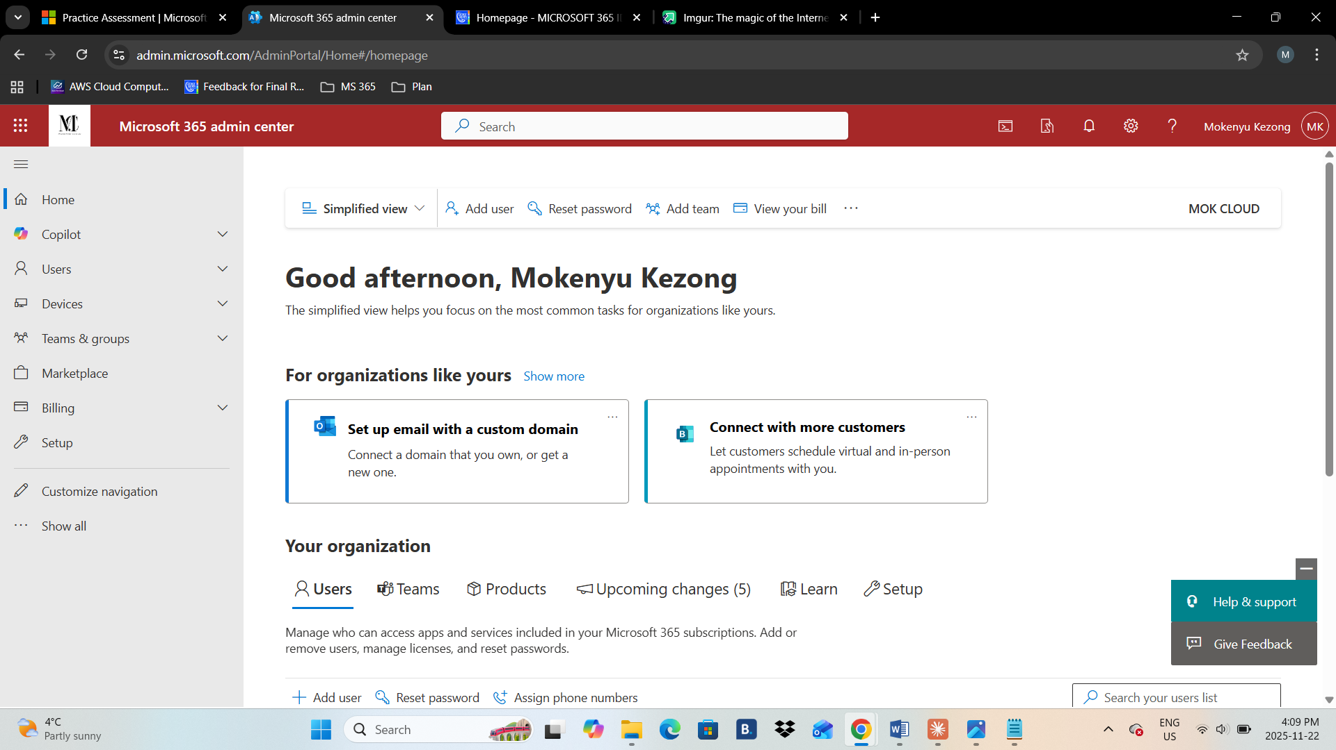
5. 1.2 Change color theme
6. 
7. 1.3 Clicking on the Logo should take you to <https://www.youtube.com/@AliZiyaei>

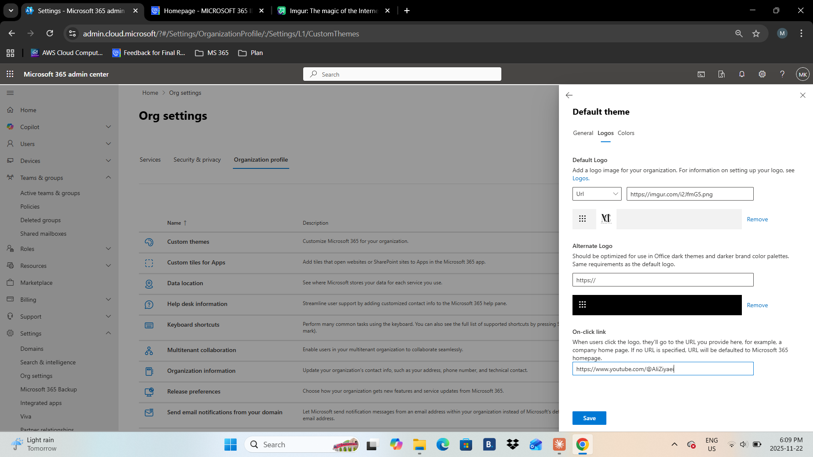

1. 1.4 Add your helpdesk contact information
2. 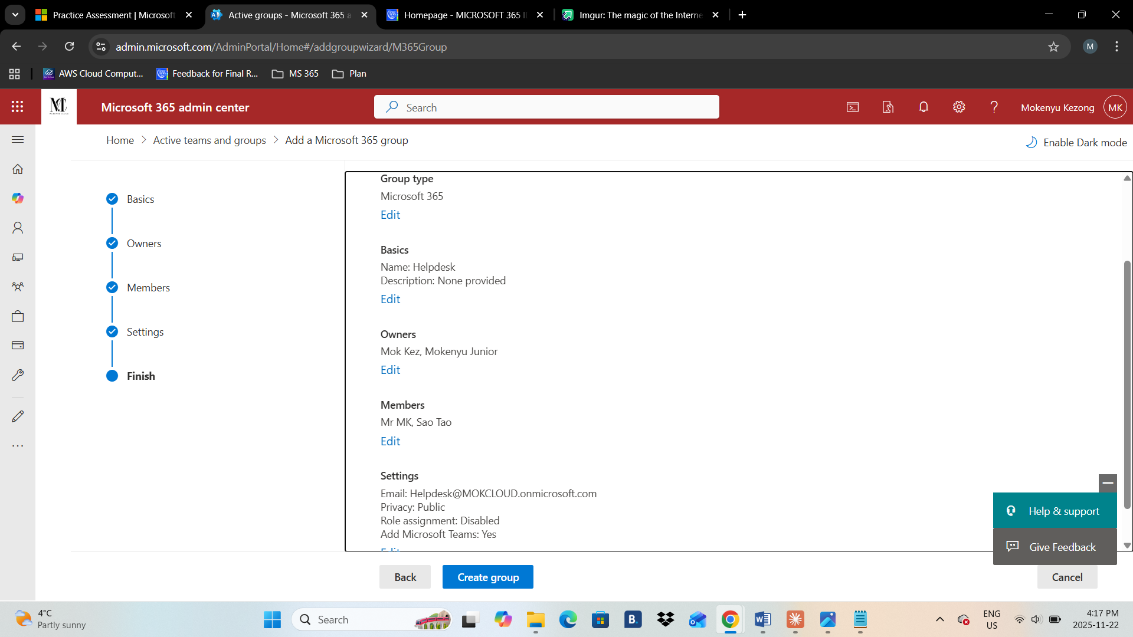

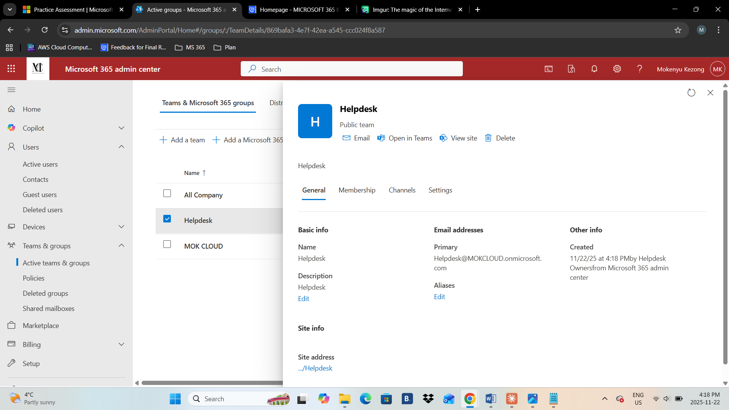

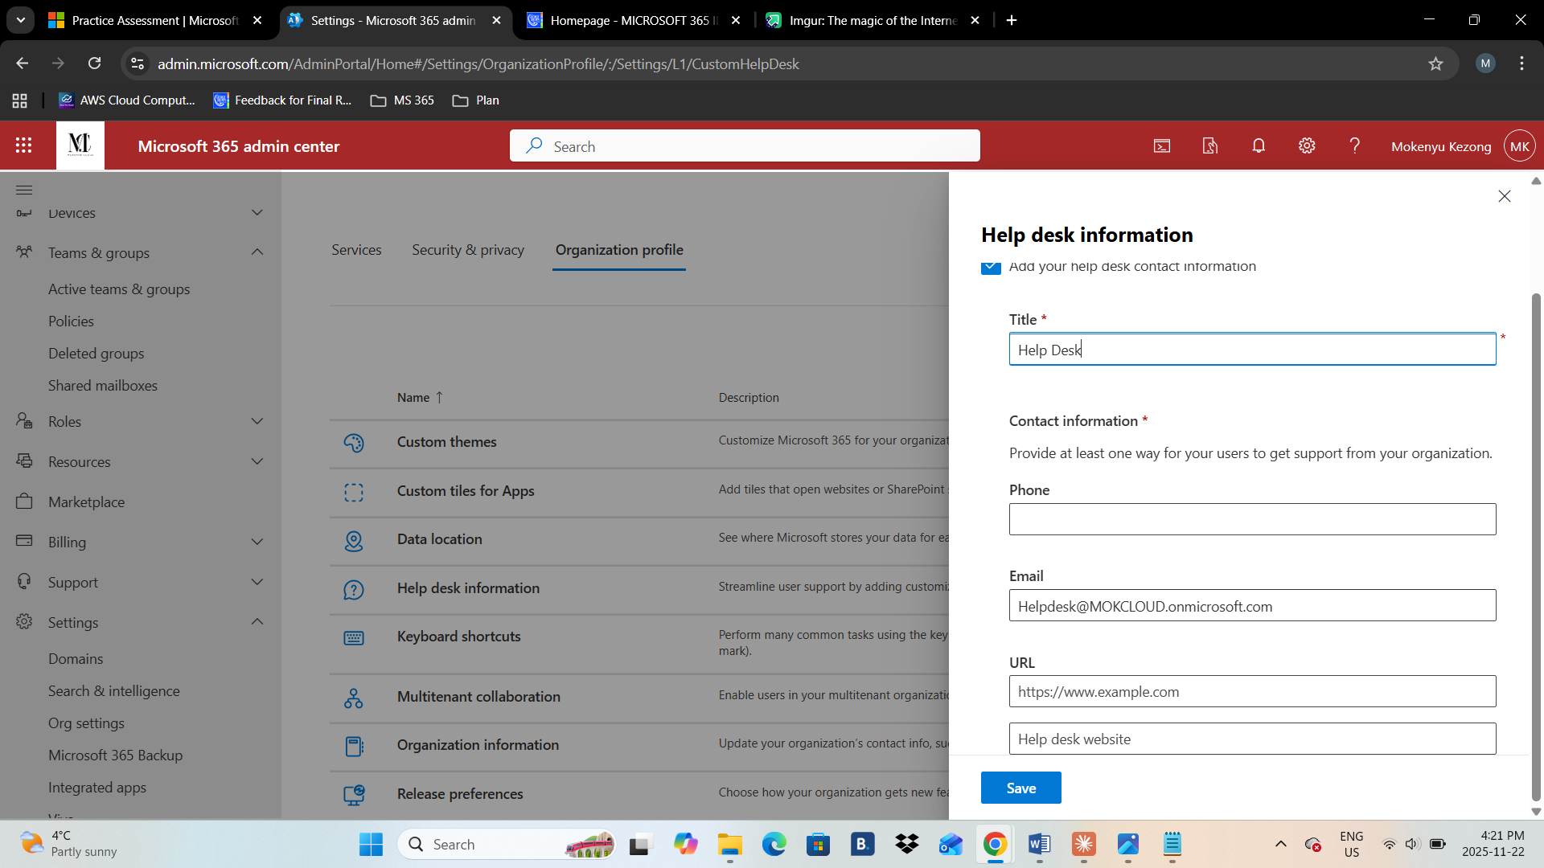

1. 1.5 Select 2 Users to receive updates before they’re released to everyone else.

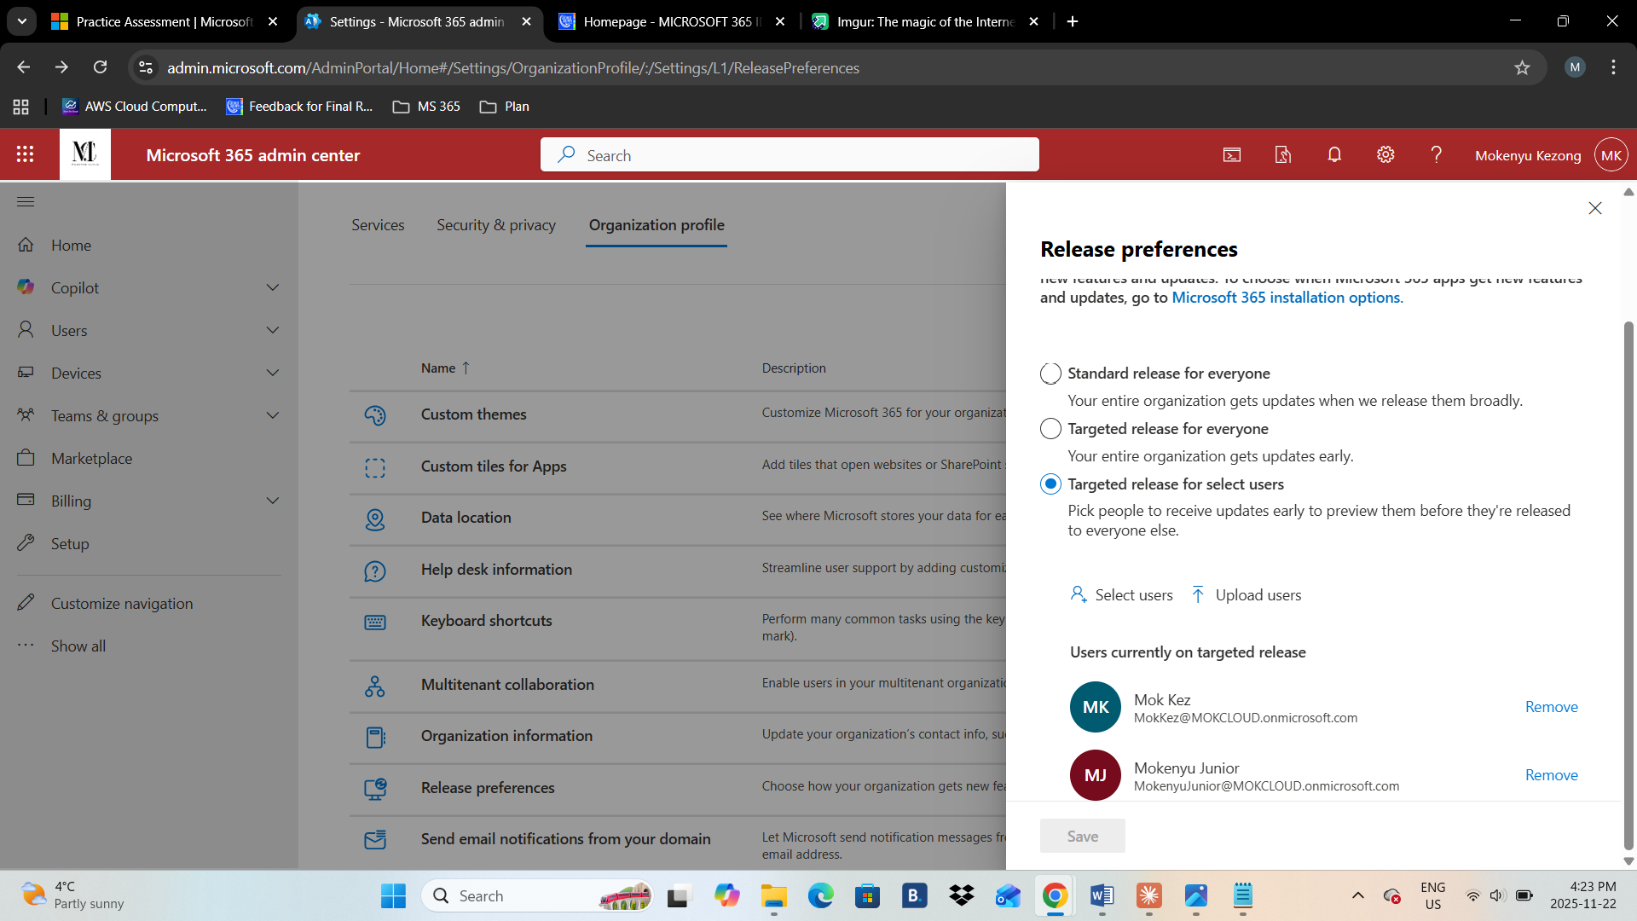

1. **Task 2: Working with PowerShell**
2. 2.1 Install the PowerShell module and connect to M365
3. 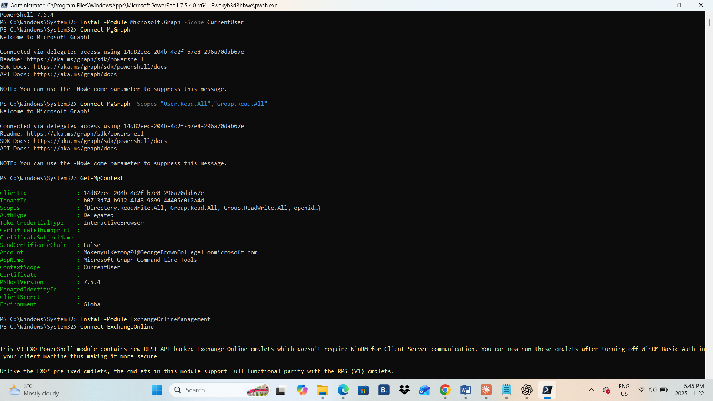
4. 2.2 Create two new users

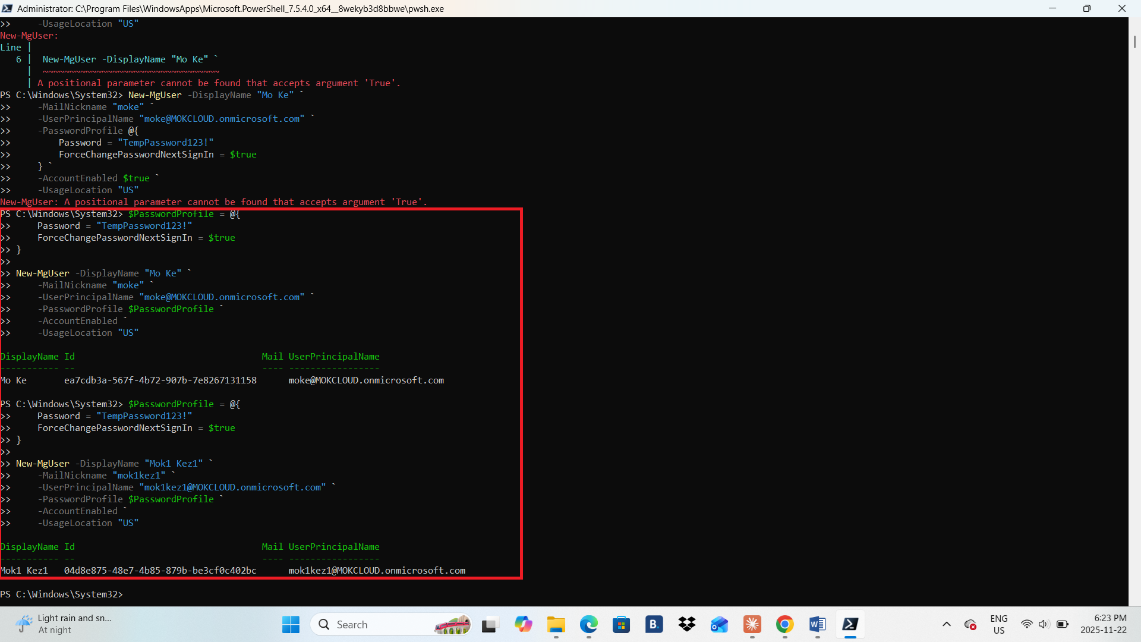

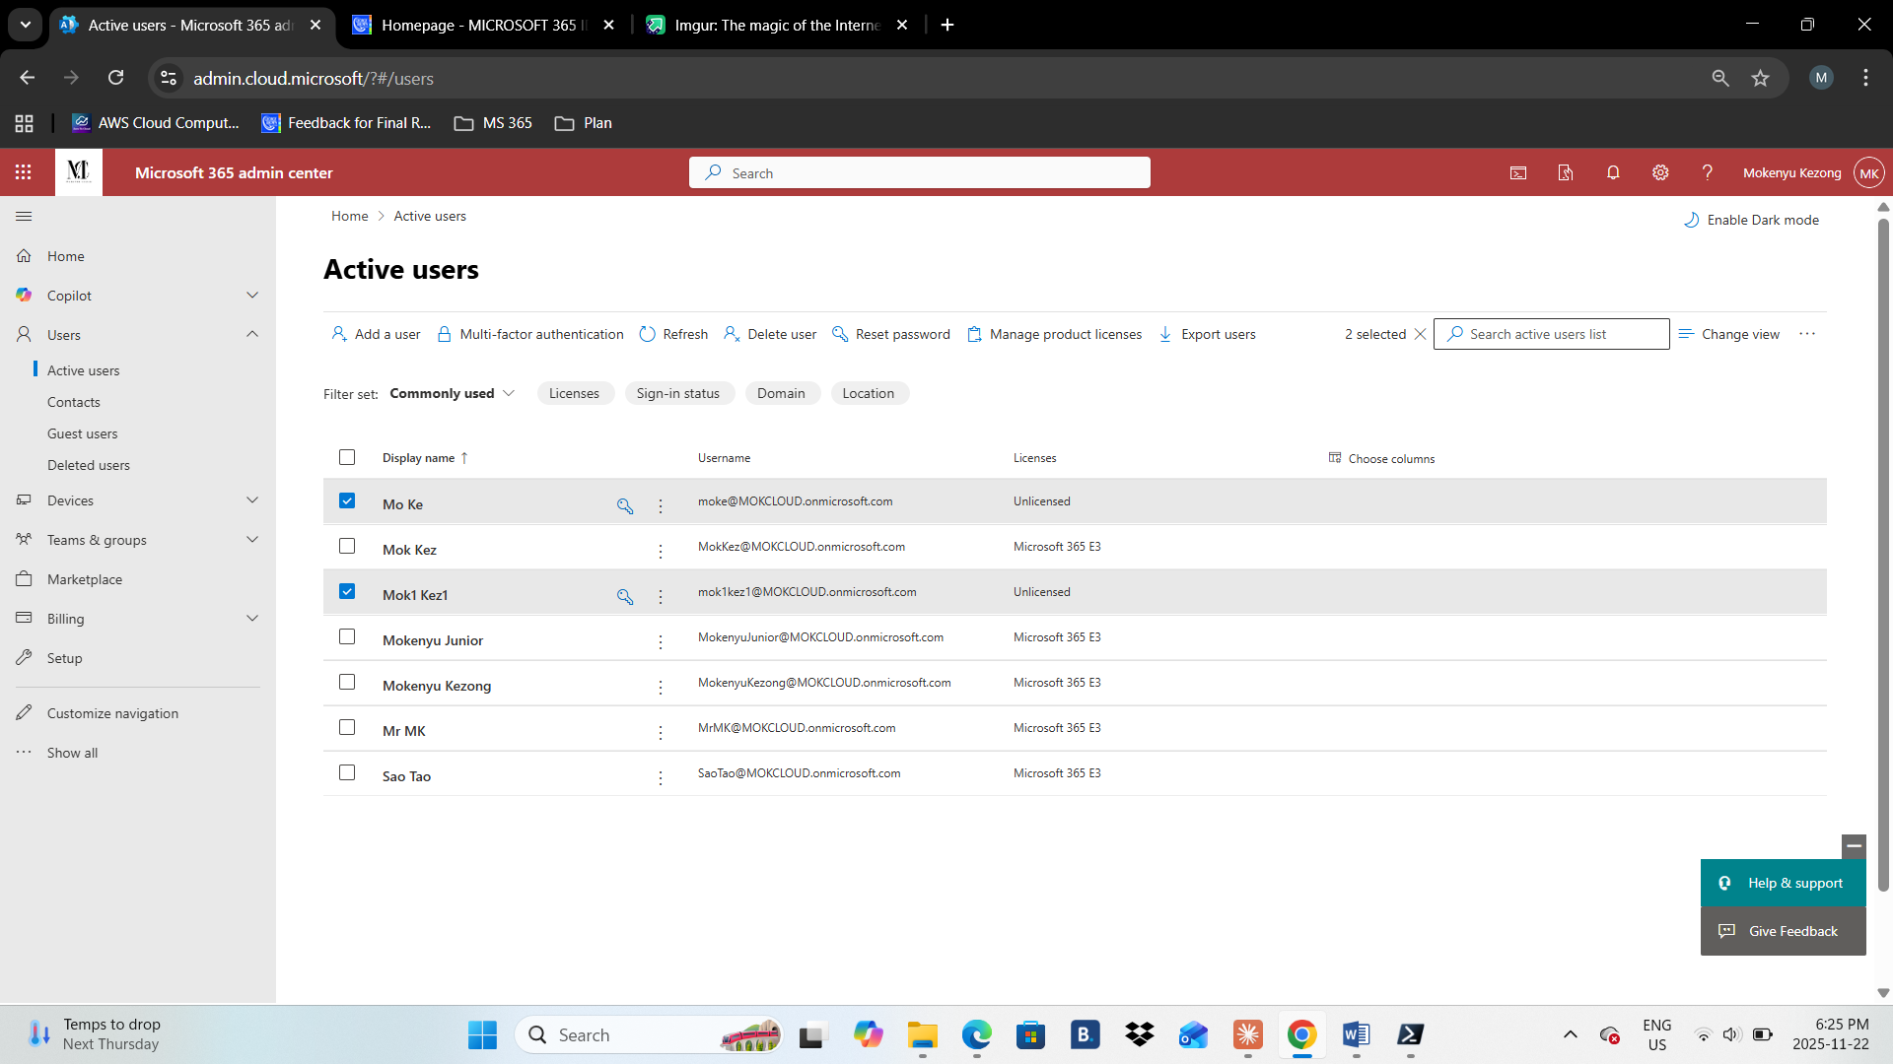

1. 2.3 Assign License to users with PowerShell

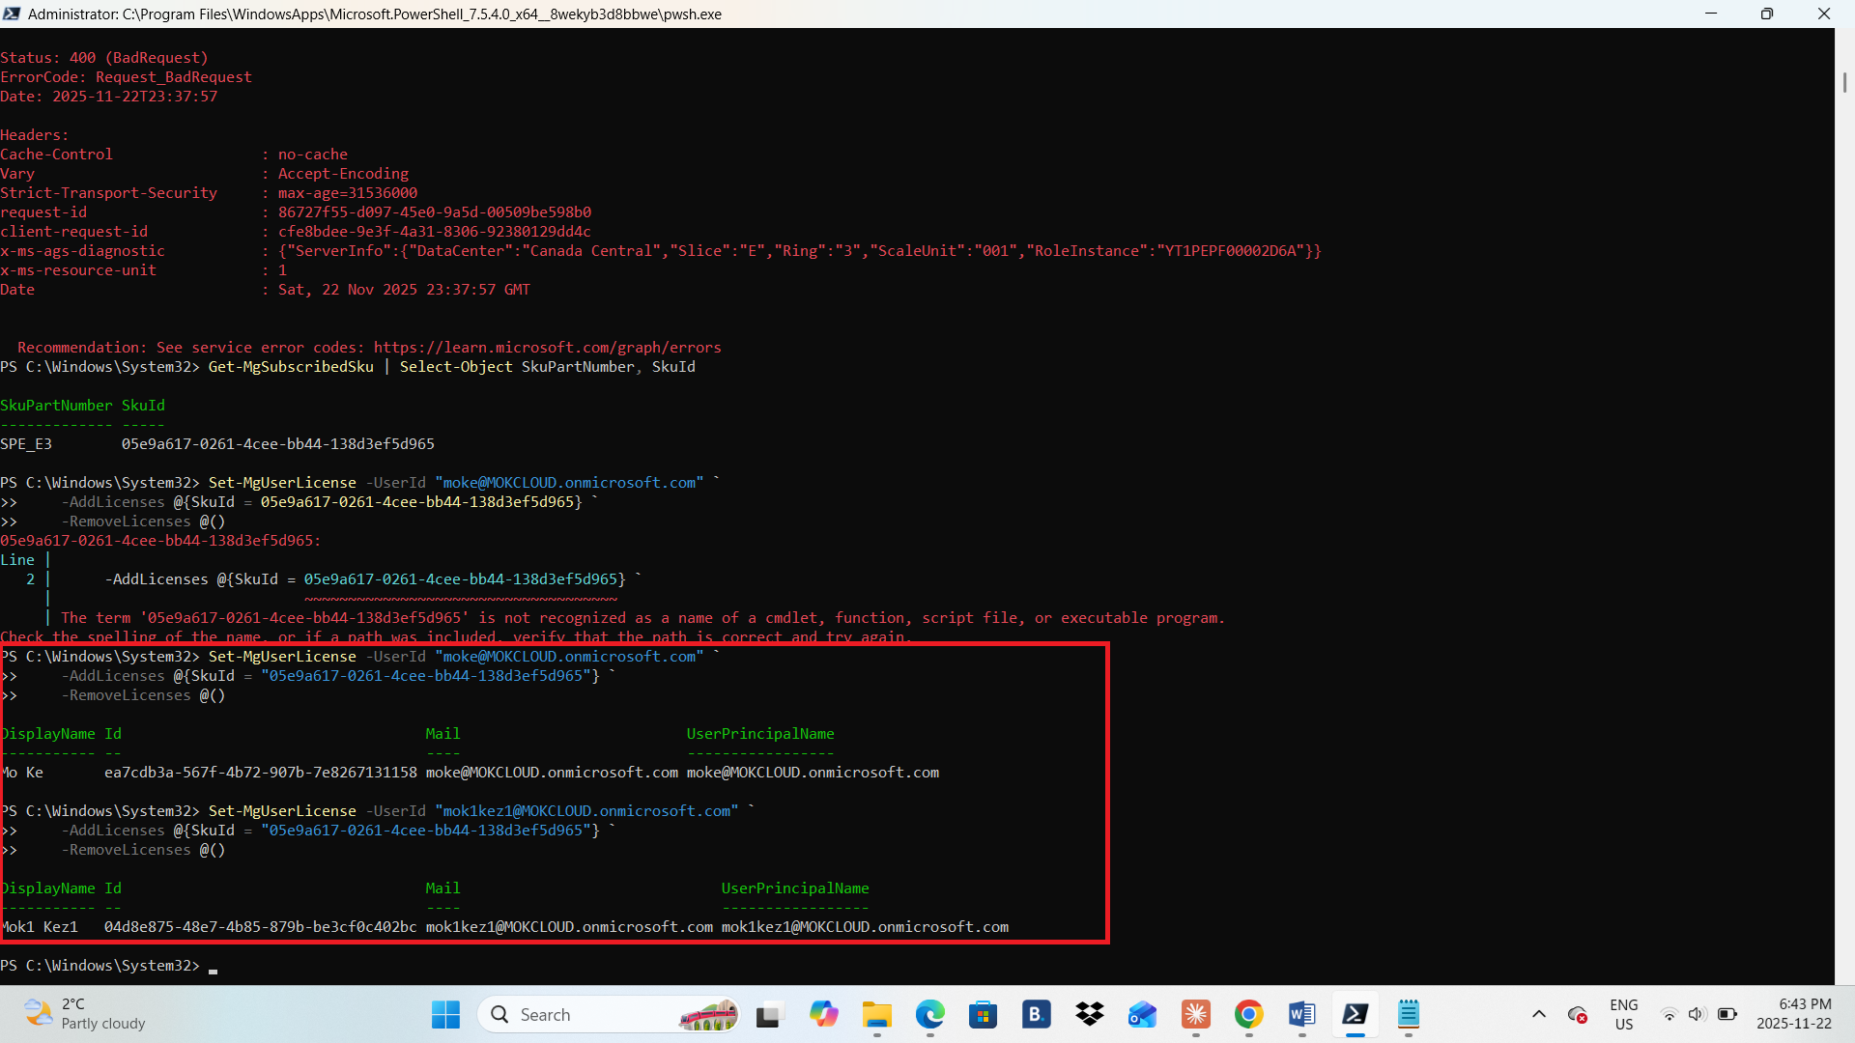

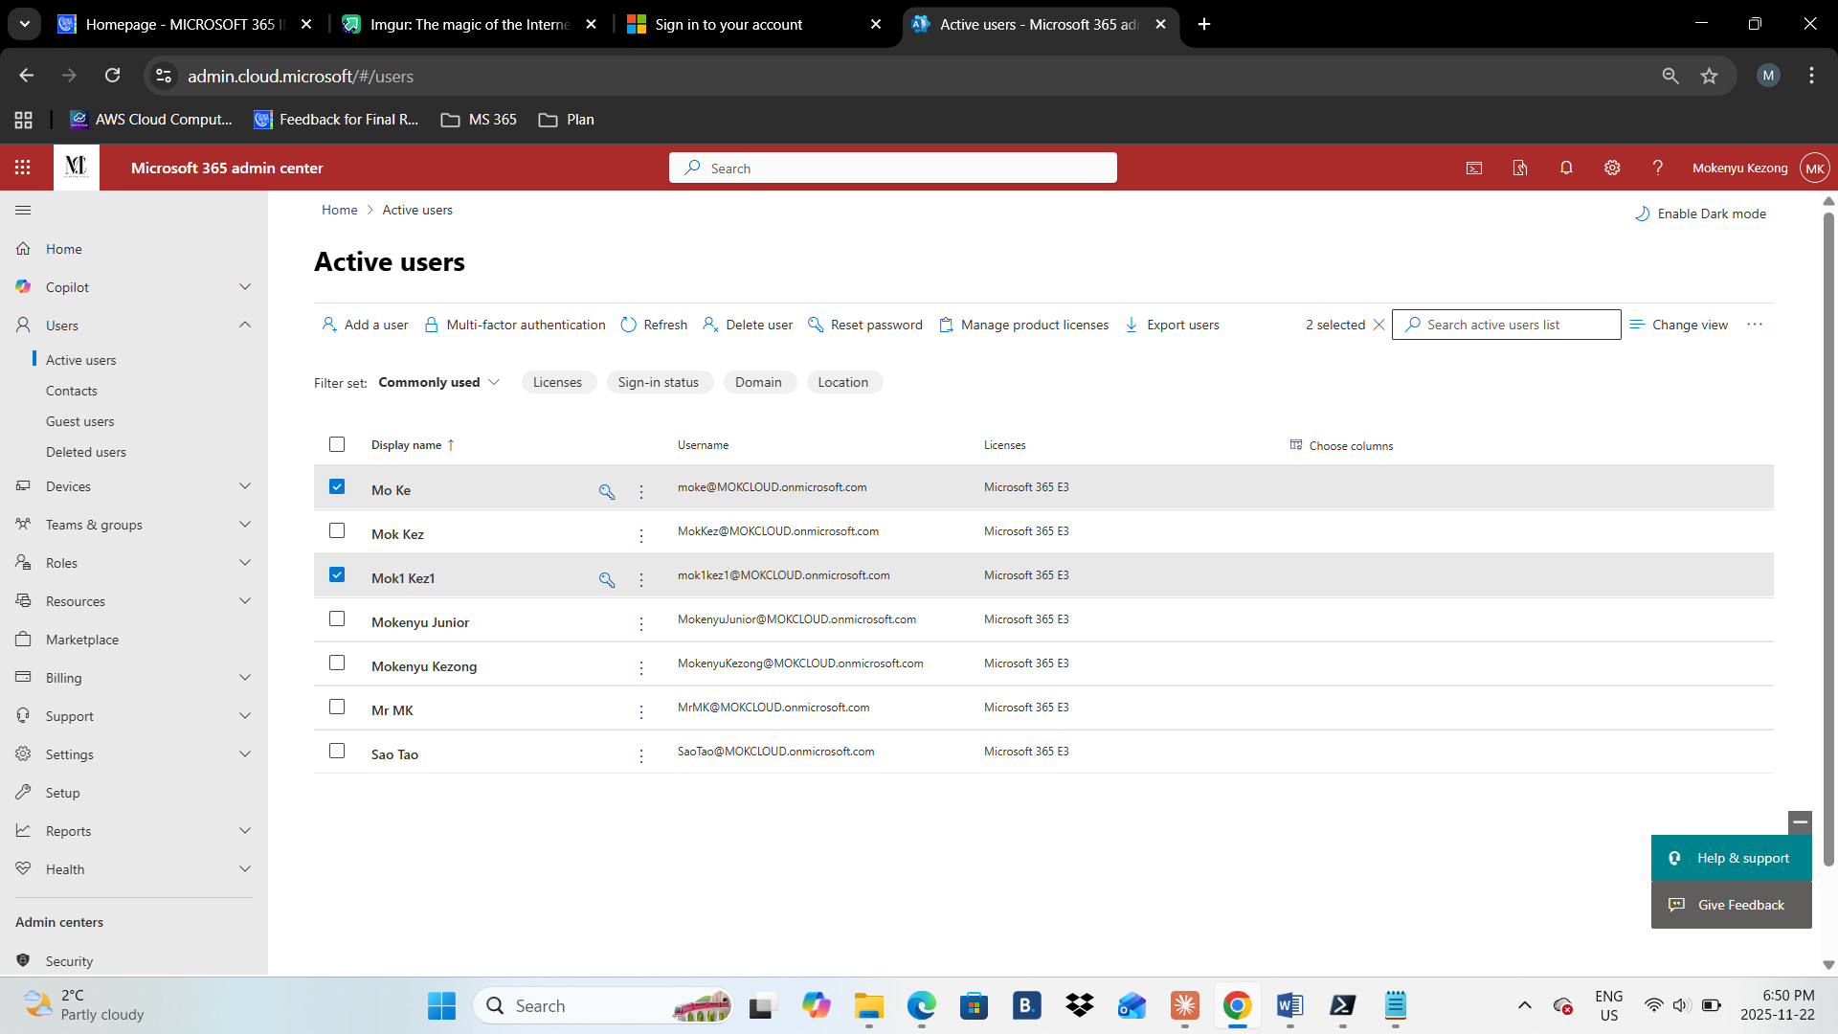

1. **Task 3: Install Microsoft 365 Apps for enterprise**
2. 3.1 Install Office on a Virtual Machine and log in with your Trial user account that you created on the previous task to Office to activate it.
3. 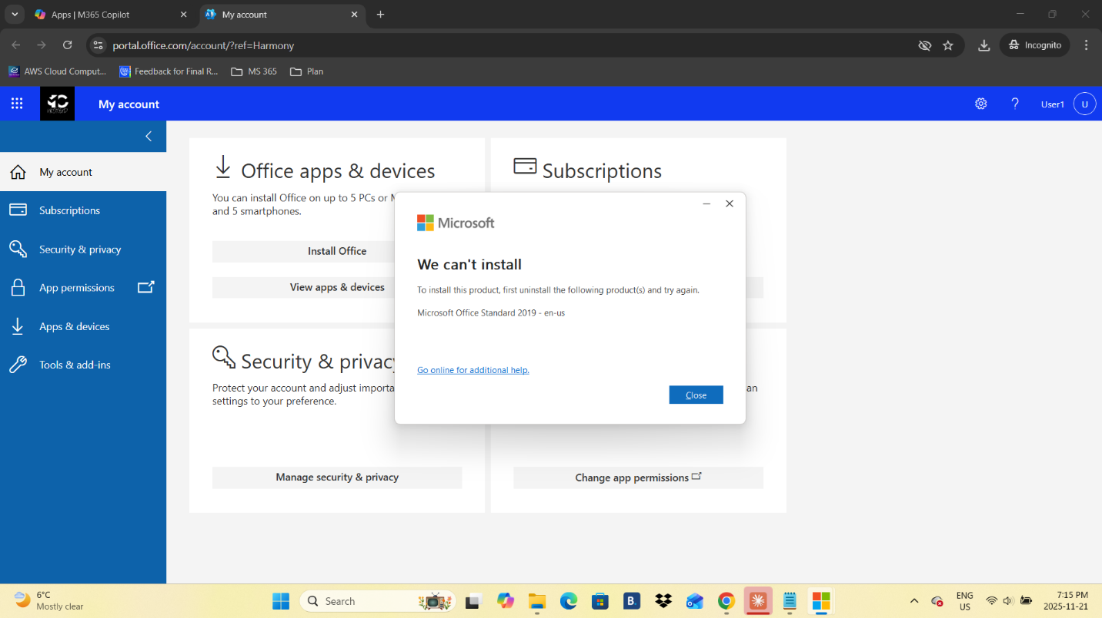
4. 3.2 Open Outlook and send an email to the other account you created on Task 2
5. 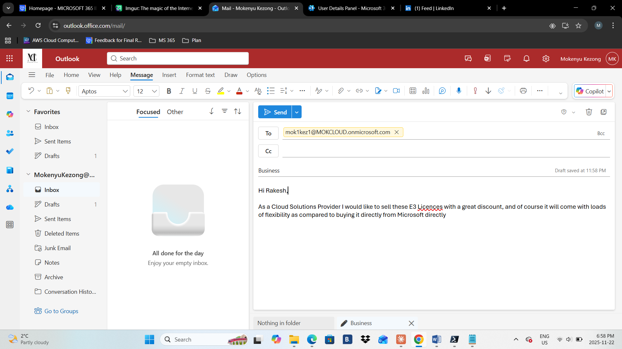
6. 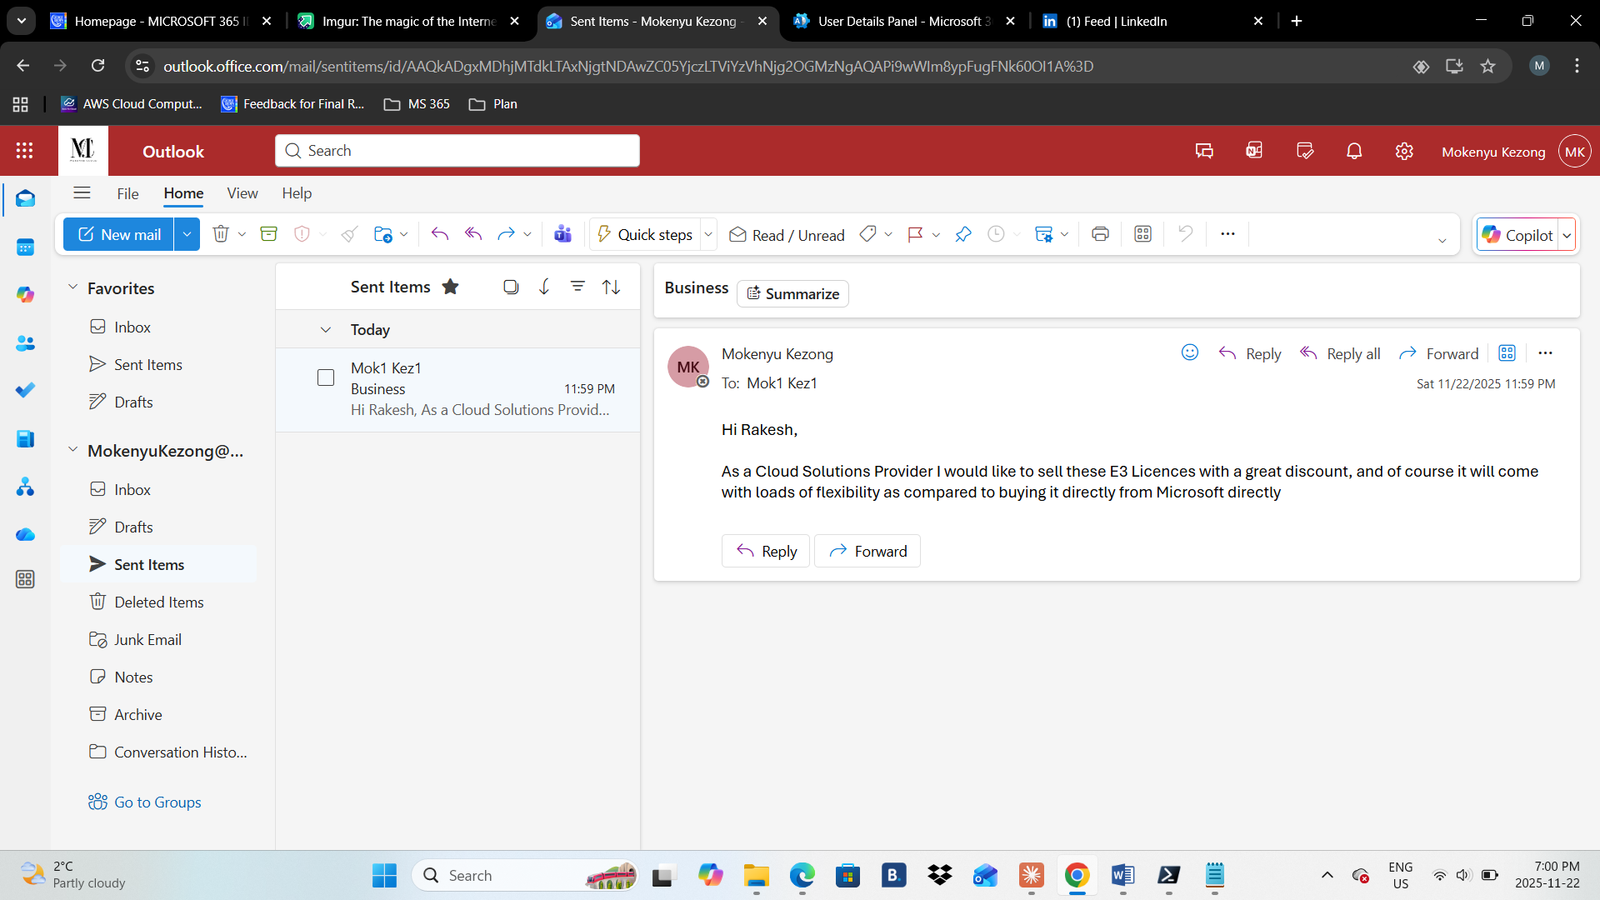
7. 3.3 From the Web, log in to the second user’s mailbox and show email was delivered.

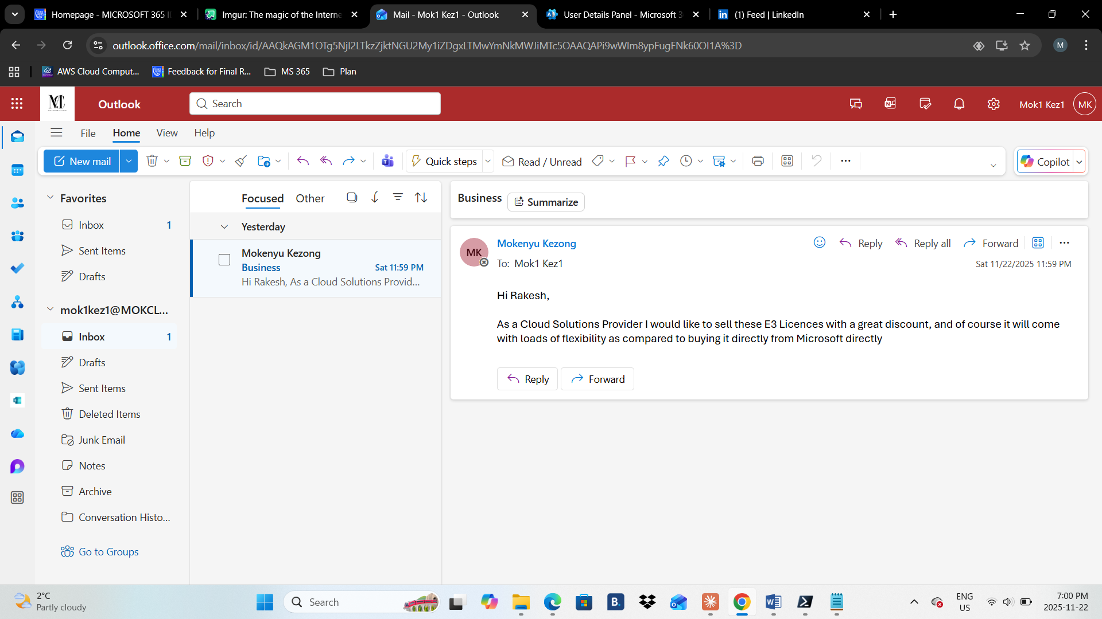

1. **Task 4: Working with Exchange**
2. 4.1 From Exchange Admin Center create a shared mailbox called yourname-Shared and give access to both users created in Task2
3. 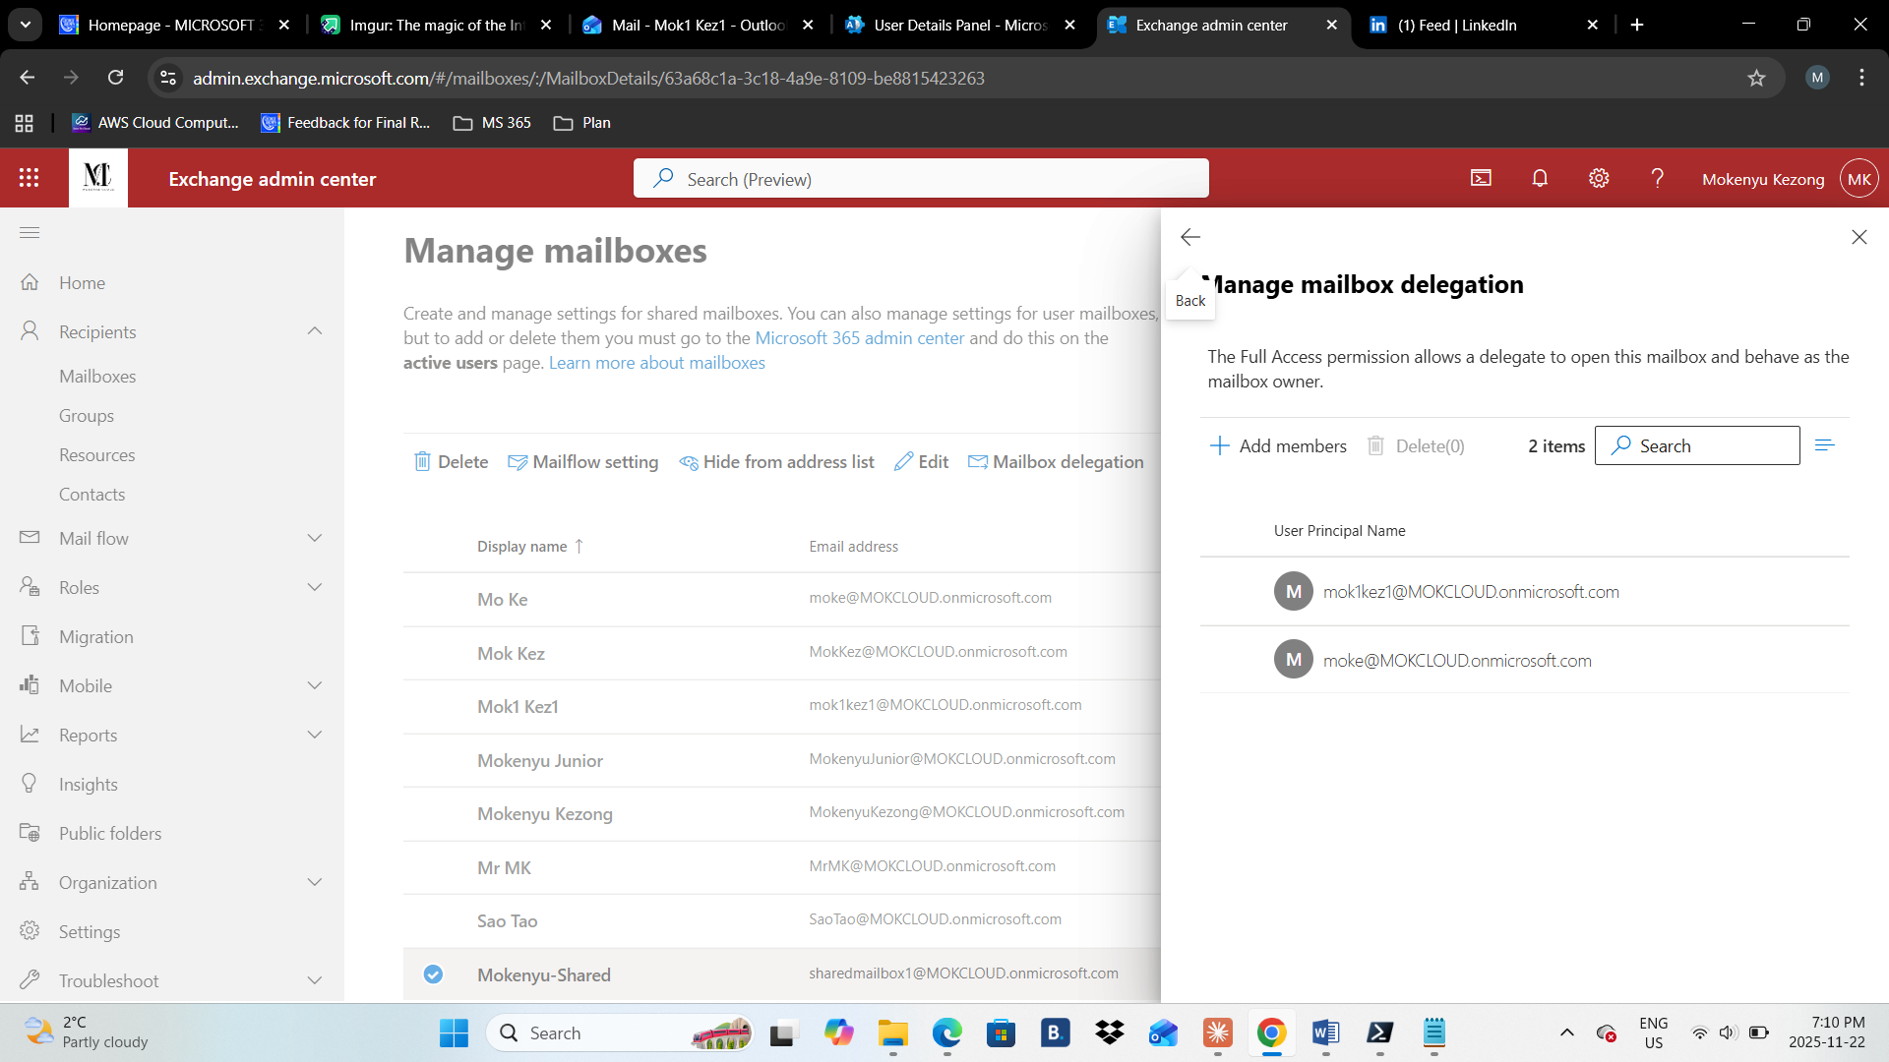
4. 4.2 From Exchange Admin Center create a distribution list called yourname-Dist and add both users from task two to this list.

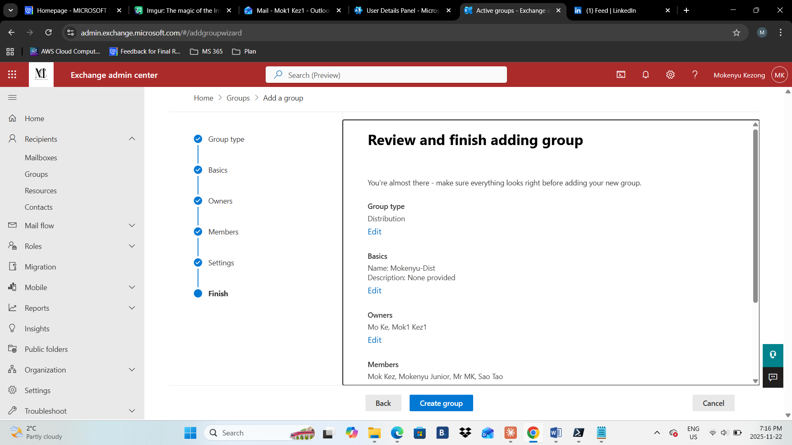

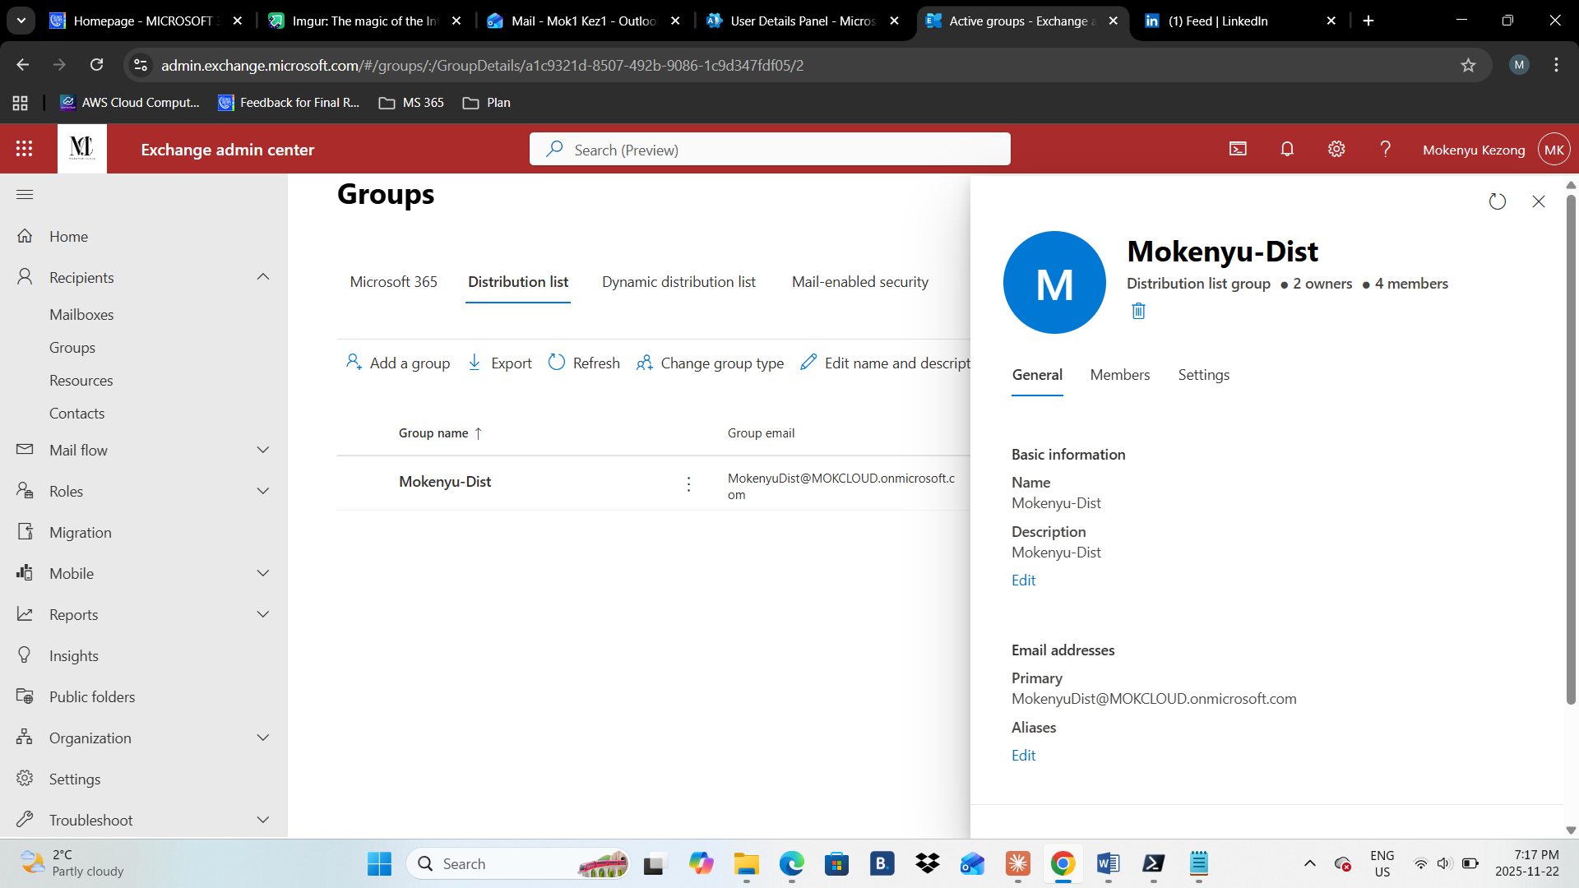

1. 4.3 Send an email to both Distribution list and Shared mailbox and show it was delivered to users’ mailbox
2. 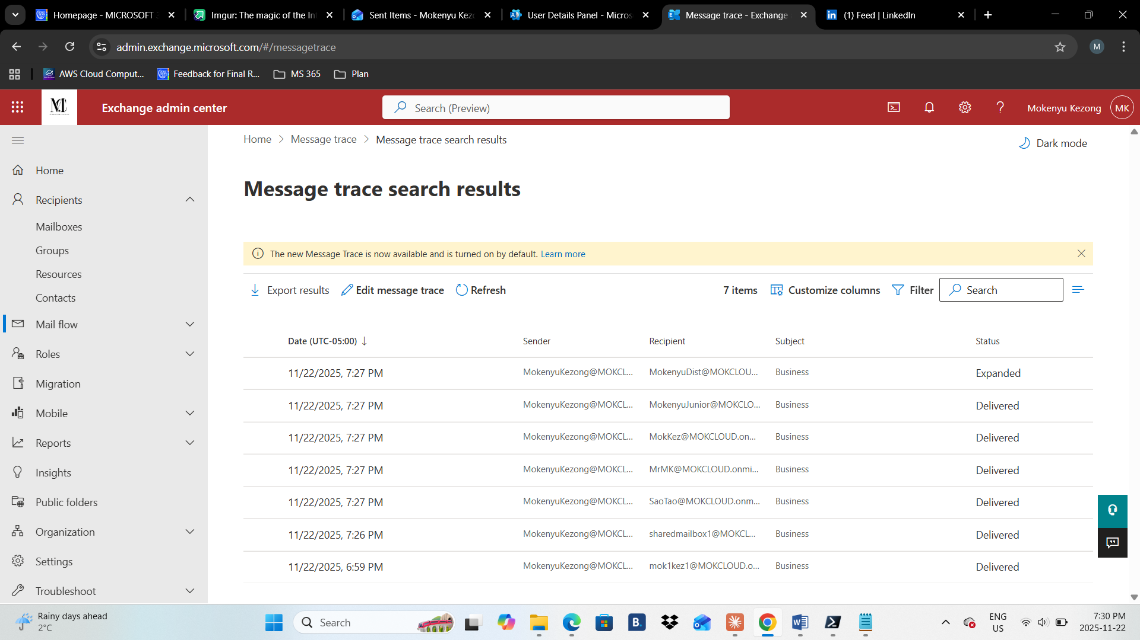
3. 4.4 Provide a screenshot of your malware settings different sections

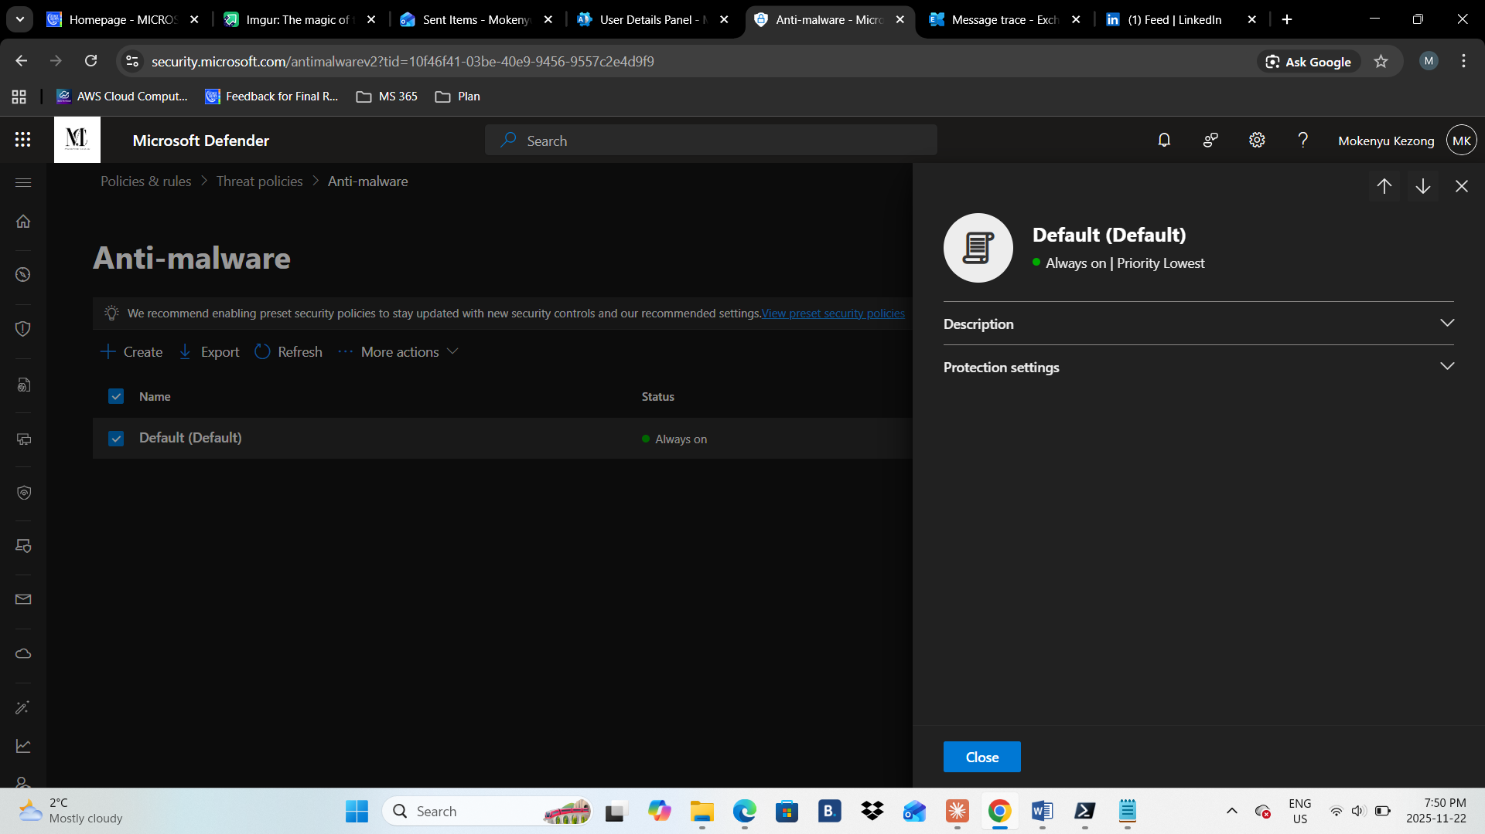

1. **Task 5: Working SharePoint**

5.1 Display your active site

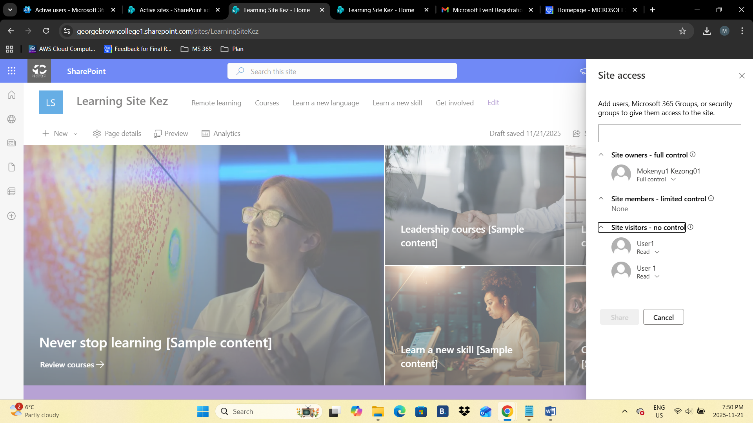

5.2 Create a new document library site called your name and add both users from Task2 to the site

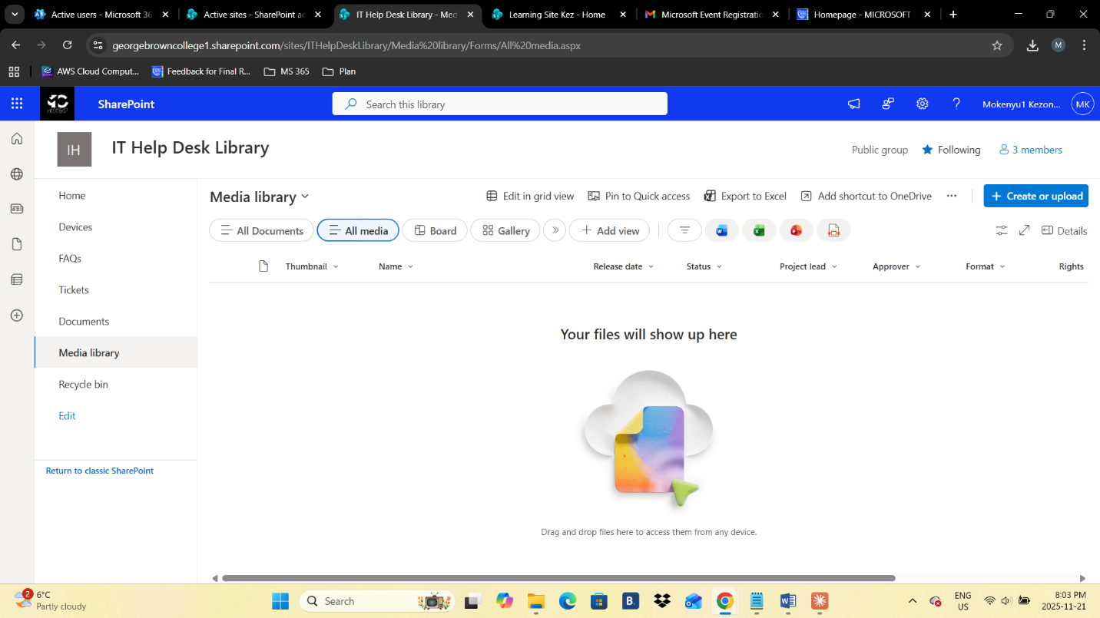

5.3 Change the sharing policy so that only People in your organization are allowed to share files over One Drive

**DO THIS FOR YOURSELF**

~~~~~~  
Paste your screenshots here